**Lab 02b - Manage Governance via Azure Policy**

***Mihail Elencevski***

#### Task 1: Assign tags via the Azure portal

*This task involves assigning a tag to an Azure resource group using the Azure portal. It aims to demonstrate how to create and manage tags in Azure.*

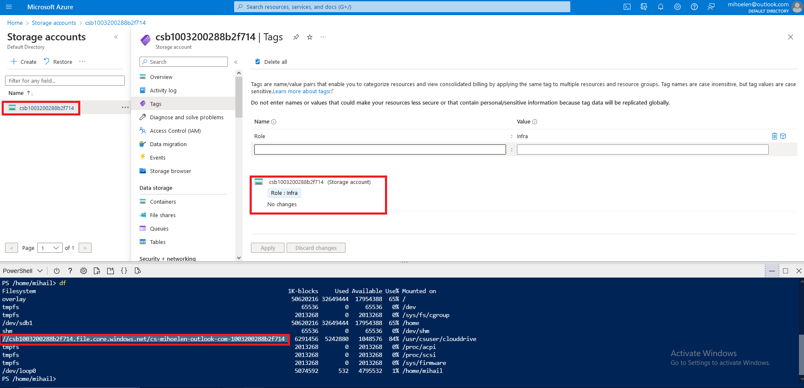

#### Task 2: Enforce tagging via an Azure policy

*This scenario involves assigning the "Require a tag and its value on resources" policy to a resource group to enforce tagging compliance. The* ***deployment must fail*** *so the task can continue. After deployment, I am checking the Notifications list to identify the reason for failure.*

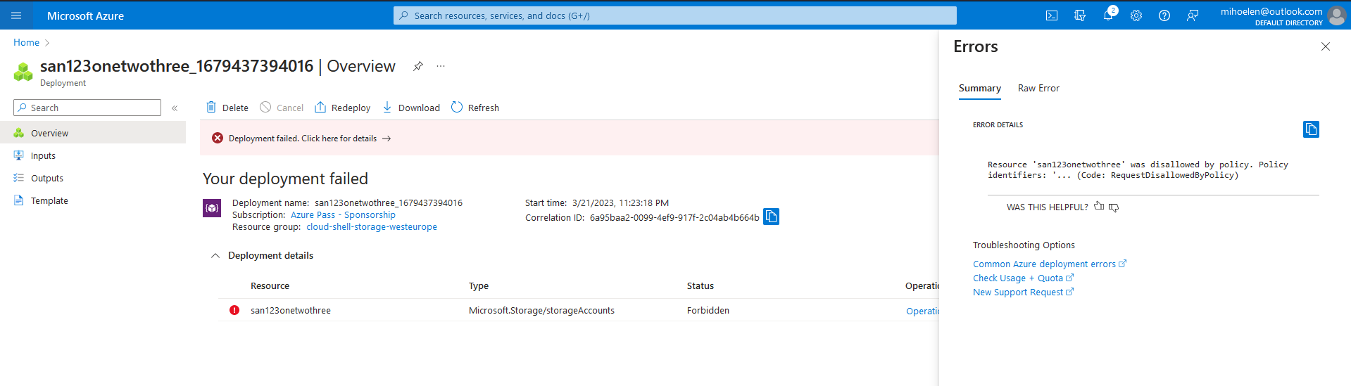

#### Task 3: Apply tagging via an Azure policy

*This task involves applying tagging via an Azure policy by using a different policy definition to remediate any non-compliant resources. The objective is to showcase how Azure policies can automatically apply tags to resources that are not compliant with tagging requirements, thereby* ***ensuring consistent tagging practices in an Azure environment.***

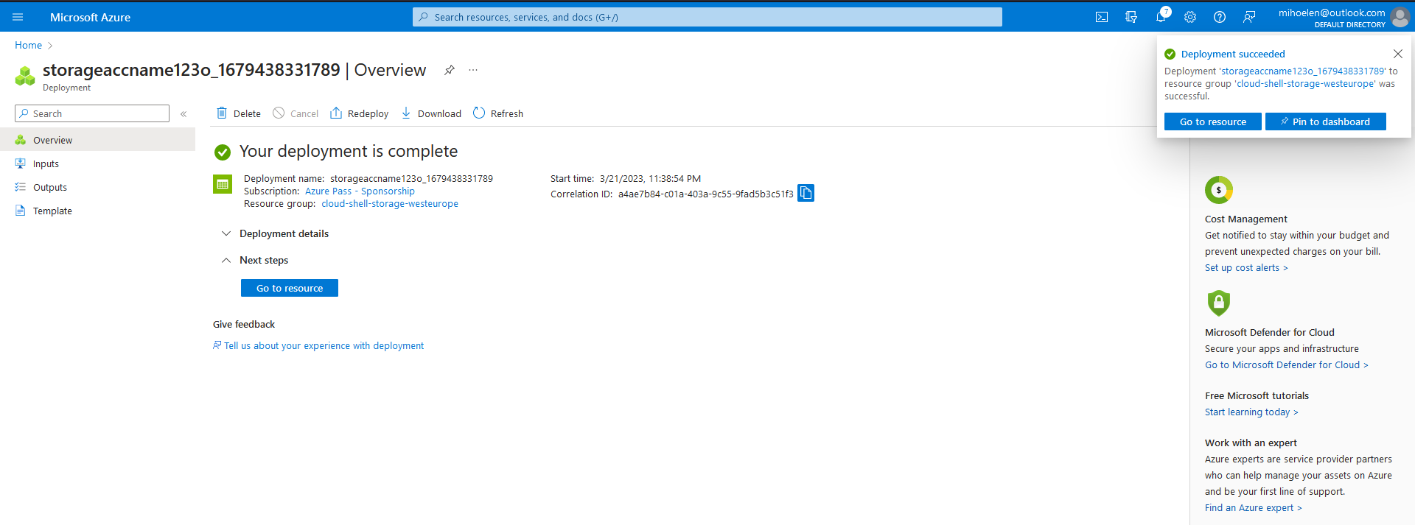

*Here after provisioning a new storage account, it's important to note that the Azure policy will* ***automatically*** *apply the tag "Role" with the value "Infra" to the resource. This step helps to verify that the policy is working as intended and ensures consistent tagging practices in the Azure environment.*

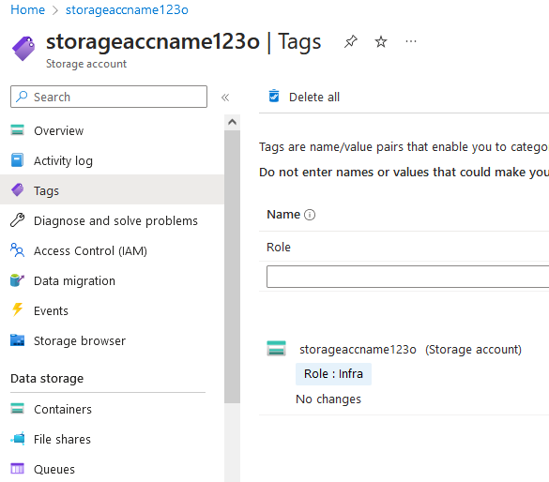

#### Task 4: Clean up resources.

